Insert Records

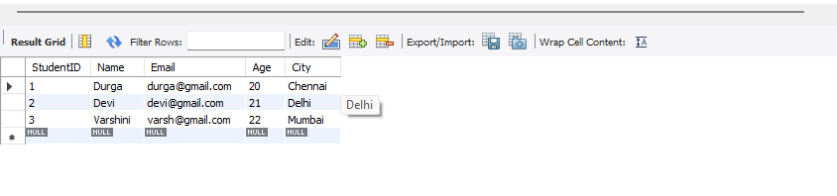

Explanation:
Three student records were successfully inserted into the Students table.
The SELECT query displays all the inserted student details.

